TITLE: CineVerse: Context-Aware AI System for Cinematic Script Translation.
NAME OF APPLICANT: Narula Institute of Technology

ADDRESS OF APPLICANT: 81 Nilgunj Road, Agarpara, Kolkata – 700109, West Bengal, India
NAME OF INVENTOR:
*Note: Address of Inventor will be same as address of applicant

- Abhishek Banerjee
- Gyan Prakash Tiwari

DETAILS OF INVENTOR
SL. NO. | NAME OF INVENTOR | PHOTO OF INVENTOR | SIGNATURE OF INVENTOR
1. | Gyan Prakash Tiwari |  | 
2.
3.

- Field of the invention:

The present invention relates generally to the field of Artificial Intelligence (AI), Natural Language Processing (NLP), computational linguistics, and automated language translation, and more particularly to an intelligent computer-implemented system for translating cinematic scripts across different natural languages. The invention is concerned with the automated processing of screenplay content including dialogues, character interactions, scene descriptions, narrative elements, and contextual information. The system utilizes computational language-processing techniques to analyze source script content and generate corresponding translated content while maintaining the semantic relationship between different components of a cinematic script. The invention is applicable to multilingual film production, digital media, audiovisual content creation, screenplay adaptation, and other applications where accurate and contextually appropriate translation of cinematic content is required.
The invention particularly relates to context-aware and emotion-preserving translation of cinematic scripts, wherein conventional word-level or sentence-level translation approaches may not adequately represent the intended meaning of a dialogue or scene in a target language. The proposed system considers contextual information associated with characters, scenes, conversational relationships, narrative situations, emotional states, cultural references, idiomatic expressions, and figures of speech during the translation process. By incorporating such contextual parameters into the computational translation workflow, the system is configured to generate target-language content that retains the intended meaning, emotional expression, character intent, and cultural relevance of the original cinematic script. The invention may employ artificial intelligence models, language models, contextual analysis modules, semantic processing techniques, and translation-generation mechanisms for performing such operations.
The field of the invention further encompasses computational adaptation and intelligent transformation of culturally dependent cinematic language for multilingual audiences. The system is designed to process expressions whose literal translation may result in loss of meaning, emotional impact, humor, cultural significance, or narrative intent, and to generate contextually suitable target-language representations. The invention may be implemented as a software-based system, cloud-based platform, local computing application, or integrated digital content-production tool. The technical field therefore includes the intersection of AI-assisted translation, NLP, computational linguistics, cultural-context processing, emotion-aware language generation, and cinematic content adaptation, providing a technological framework for automated and context-sensitive multilingual transformation of screenplay content.

- Background of the invention:

The growth of multilingual digital media and global distribution of films and audiovisual content has increased the requirement for efficient translation and adaptation of cinematic scripts across different natural languages. Conventional translation systems generally rely on statistical, rule-based, or neural language translation techniques that primarily focus on converting words, phrases, or sentences from a source language into a target language. Although such systems can provide grammatically acceptable translations, cinematic scripts contain contextual and expressive elements that extend beyond literal linguistic meaning. Dialogue in a screenplay is frequently influenced by a character's personality, relationships with other characters, scene situations, emotional state, narrative progression, cultural background, and intended audience. Consequently, direct or sentence-level translation may fail to preserve the intended meaning and communicative purpose of the original content.

A particular limitation of existing automated translation approaches is the inadequate handling of **context-dependent expressions, idioms, metaphors, humor, sarcasm, cultural references, and emotionally expressive dialogue**. A phrase that has one literal meaning in a source language may convey a substantially different meaning when interpreted within a particular cinematic scene. Similarly, direct translation of culturally specific expressions may produce text that is linguistically correct but inappropriate or unnatural for the target audience. Existing systems may also process individual sentences independently, resulting in inconsistencies in character-specific speech patterns, emotional tone, terminology, and narrative context throughout a screenplay. Manual post-editing by translators or screenplay professionals is therefore frequently required to correct contextual and cultural inconsistencies, increasing the time, effort, and cost associated with multilingual content adaptation.

Accordingly, there exists a need for an improved **AI-assisted cinematic script translation system** capable of considering broader screenplay context rather than relying solely on isolated linguistic units. Such a system should be capable of analyzing relevant contextual information, including scene descriptions, character identity, dialogue relationships, emotional cues, cultural references, idiomatic expressions, and narrative circumstances, before generating translated content. There is further a need for a computational mechanism that can preserve the semantic intent and emotional characteristics of cinematic dialogue while adapting culturally dependent expressions into an appropriate target-language form. Addressing these limitations can facilitate more consistent, context-sensitive, and efficient multilingual transformation of cinematic scripts while reducing dependence on extensive manual adaptation.

- Summary of the invention:

The present invention provides an **artificial intelligence-based context-aware cinematic script translation system and method** configured to translate screenplay content from a source language into a target language while preserving contextual meaning, emotional expression, cultural relevance, and character intent. The system receives cinematic script content comprising one or more dialogues, scene descriptions, character information, and associated narrative elements as input. The received content is processed through a contextual analysis mechanism that identifies relevant linguistic and cinematic characteristics, including semantic meaning, character relationships, emotional cues, idiomatic expressions, cultural references, figures of speech, and scene-level context. The analyzed information is subsequently provided to an AI-based language generation and translation mechanism for producing contextually appropriate translated screenplay content.

In one embodiment, the system comprises a **script input module, screenplay parsing module, contextual analysis module, character and scene context extraction module, emotion and intent analysis module, cultural and idiomatic expression processing module, AI-based translation and generation module, consistency validation module, and translated script output module**. The screenplay parsing module separates and identifies different structural elements of the input script, while the contextual analysis module establishes relationships between dialogues, characters, scenes, and narrative events. The emotion and intent analysis mechanism determines relevant emotional characteristics and communicative intent, and the cultural processing mechanism identifies expressions that require contextual adaptation rather than literal translation. Based on the extracted information, the AI-based translation mechanism generates target-language content while maintaining continuity of character voice, scene context, emotional tone, and narrative intent.

The invention further provides a context-sensitive computational workflow for intelligent cinematic language adaptation, wherein generated translations may be evaluated using semantic, contextual, emotional, cultural, and linguistic consistency parameters. Where required, the system may identify potential inconsistencies or contextually inappropriate translations and perform corrective processing before presenting the final output. The resulting translated script can be provided in a structured screenplay format suitable for subsequent review, editing, localization, or audiovisual production. The invention thereby provides a technical framework for automated multilingual transformation of cinematic scripts that addresses limitations associated with isolated sentence-level translation by incorporating screenplay-level contextual information into the translation and generation process.

In a further aspect, the invention offers a unified platform for AI governance, compliance validation, and trustworthy AI deployment. By integrating predictive digital twin modeling, bias risk forecasting, fairness assessment, autonomous optimization, and continuous monitoring capabilities, Fair Verse enables the development of transparent, accountable, and equitable AI systems. The invention is applicable across various sectors, including healthcare, finance, insurance, education, recruitment, public services, and autonomous technologies, where fairness, non-discrimination, and ethical decision-making are critical operational requirements.Additionally, the proposed innovation offers scalability for multilingual and multi-script handwritten recognition applications. The framework may be extended to recognize regional languages, alphanumeric characters, symbols, and document-level handwritten content. By combining adaptive preprocessing, hybrid intelligent classification, and edge computing capability within a unified framework, the invention provides a robust, scalable, and computationally optimized solution for next-generation handwritten recognition systems operating in dynamic and real-world environments.Bottom of Form
- Description of the invention: (including flow diagram, results, etc.)
The present invention, referred to herein as CineVerse, provides a computer-implemented artificial intelligence system and method for context-aware translation and cultural adaptation of cinematic scripts. The system is configured to receive a source-language screenplay as an input and generate a corresponding target-language screenplay while considering contextual, semantic, emotional, cultural, and character-specific information. Unlike conventional translation workflows that primarily process individual sentences or textual segments, the proposed system processes the screenplay as an interconnected sequence of scenes, characters, dialogues, and narrative events. The system may be implemented as a software application, web-based platform, cloud-based service, local computing system, or a combination thereof.
In an embodiment of the invention, the system comprises a Script Input Module (101) configured to receive screenplay content in a supported digital or textual format. The received screenplay is supplied to a Screenplay Parsing Module (102), which identifies and separates structural components such as scene headings, character names, dialogue, action descriptions, stage directions, and other screenplay elements. The parsed information is stored as structured contextual data for subsequent processing. A Scene and Character Context Module (103) analyzes relationships between characters and scenes and determines relevant contextual information such as speaker identity, interaction between characters, preceding and succeeding events, and scene-level narrative information. This contextual information enables subsequent translation operations to consider information beyond the immediate sentence or dialogue being translated.
The system further comprises an Emotion and Intent Analysis Module (104) configured to analyze dialogue and associated screenplay information to determine relevant emotional characteristics, communicative intent, and tone. The module may identify characteristics such as anger, happiness, sadness, fear, sarcasm, affection, urgency, humor, or other context-dependent expressions. A Cultural and Idiomatic Analysis Module (105) identifies idioms, metaphors, culturally dependent expressions, figures of speech, colloquialisms, and other linguistic constructs for which direct word-to-word translation may not adequately represent the intended meaning. The identified information is combined with the structural and contextual information obtained from the preceding modules to form a Context Representation (106) associated with the screenplay segment.
The Context Representation (106) is provided to an AI-Based Translation and Generation Module (107). The module may employ one or more artificial intelligence or large language model-based computational techniques to generate a target-language representation of the source content. During generation, the module considers the source meaning together with scene context, character information, emotional characteristics, communicative intent, cultural information, and previously generated or related screenplay content. The generated output is therefore not restricted to direct lexical substitution and may adapt context-dependent expressions into target-language expressions that correspond to the intended cinematic meaning. The system may further maintain character-specific terminology, speech patterns, and contextual continuity across multiple dialogues and scenes.
The generated translation is subsequently supplied to a Translation Consistency and Validation Module (108). This module evaluates the generated content against one or more parameters including semantic consistency, contextual consistency, emotional correspondence, character continuity, cultural appropriateness, linguistic correctness, and screenplay structural consistency. In an embodiment, the validation module may identify discrepancies between the source content, extracted contextual information, and generated translation. When a discrepancy is detected, the relevant content may be returned to the AI-Based Translation and Generation Module (107) for corrective or iterative generation. Such iterative processing may continue until predefined validation conditions are satisfied or a suitable translated representation is obtained.
Following validation, the processed content is supplied to a Script Formatting and Output Module (109). The module reconstructs the translated content into a structured screenplay representation while retaining relevant screenplay components such as scene headings, character identifiers, dialogue, action descriptions, and associated formatting. The final output may be displayed through a user interface, stored in a digital database, exported as a document, or supplied to another content-production system. The output may additionally contain contextual metadata or translation information for subsequent human review and editing.
The overall operation of the invention may be represented as a sequential or iterative workflow comprising: receiving source screenplay content; parsing screenplay elements; extracting scene and character context; analyzing emotion and communicative intent; identifying cultural and idiomatic expressions; generating a contextual representation; performing AI-based translation and generation; validating the generated translation; performing corrective processing where required; and generating the final target-language screenplay. The modules may operate independently or in combination, and their functions may be implemented using software instructions executed by one or more processors, machine-learning models, language models, databases, application programming interfaces, or other suitable computational components.
In another embodiment, the system maintains cross-scene and cross-dialogue contextual information to improve consistency throughout the screenplay. Information associated with previously processed scenes may be retained as contextual memory and supplied during processing of subsequent scenes. Such information may include character identities, relationships, recurring terminology, emotional progression, culturally significant references, and narrative events. This enables the system to reduce inconsistencies that may arise when each dialogue is translated independently.
The invention may further support a human-in-the-loop review mechanism, through which a user can inspect, modify, approve, or regenerate a translated segment. User modifications may be incorporated into subsequent processing to improve consistency within the remaining screenplay. The system may also permit configuration of source language, target language, translation preferences, contextual parameters, and output format according to the requirements of a particular cinematic production.
Accordingly, the invention establishes an integrated computational framework in which screenplay structure, contextual information, character identity, emotional characteristics, cultural references, linguistic meaning, and AI-based language generation are jointly utilized during cinematic script translation. The technical architecture enables the translation process to operate at screenplay and scene context levels rather than relying exclusively on isolated textual segments, thereby providing a systematic mechanism for generating context-sensitive multilingual cinematic content suitable for review, localization, adaptation, and subsequent audiovisual production.

- Claim
1. A computer-implemented context-aware cinematic script translation system, comprising: a script input module configured to receive a source-language cinematic script; a screenplay parsing module configured to identify scene headings, character identifiers, dialogues, action descriptions and narrative elements; a contextual analysis module configured to establish relationships among scenes, characters, dialogues and narrative events; an emotion and intent analysis module configured to determine emotional characteristics and communicative intent associated with dialogue; a cultural and idiomatic analysis module configured to identify culturally dependent expressions, idioms, metaphors and figures of speech; an artificial intelligence-based translation and generation module configured to generate target-language cinematic content using the analyzed screenplay context; and a validation module configured to evaluate the generated content for semantic, contextual, emotional, cultural, character and structural consistency before generating a translated screenplay output.
2. The system as claimed in claim 1, wherein the contextual analysis module is configured to construct a multi-level context representation comprising at least scene-level context, character-level context, dialogue-level context and narrative-level context, wherein said context representation is provided to the artificial intelligence-based translation and generation module during translation.
3. The system as claimed in claim 1, wherein the character context module is configured to maintain character-specific linguistic characteristics, including character identity, relationship with other characters, recurring terminology, speech patterns and contextual communication style, and wherein such characteristics are utilized during translation of subsequent dialogues associated with the corresponding character.
4. The system as claimed in claim 1, wherein the emotion and intent analysis module is configured to determine one or more emotional or communicative attributes associated with a source dialogue and provide the determined attributes as contextual parameters to the artificial intelligence-based translation and generation module for generating a target-language dialogue corresponding to the determined attributes.
5. The system as claimed in claim 1, wherein the cultural and idiomatic analysis module is configured to distinguish between literal linguistic content and context-dependent expressions, and wherein an identified idiom, metaphor, cultural reference, colloquial expression or figure of speech is transformed into a target-language representation based on contextual meaning rather than direct word-to-word substitution.
6. The system as claimed in claim 1, wherein the artificial intelligence-based translation and generation module is configured to utilize cross-scene contextual memory containing information from previously processed screenplay portions, including character relationships, recurring expressions, narrative events and terminology, for maintaining contextual continuity during translation of subsequently processed screenplay portions.
7. The system as claimed in claim 1, wherein the validation module is configured to perform a multi-parameter consistency evaluation of generated translation by comparing the generated content with at least semantic meaning, screenplay context, emotional characteristics, character intent, cultural interpretation and screenplay structure, and to identify one or more contextually inconsistent portions.
8. The system as claimed in claim 7, wherein, upon detection of a contextual inconsistency, the validation module is configured to initiate an iterative corrective translation process by supplying the identified inconsistency and corresponding contextual information to the artificial intelligence-based translation and generation module for regeneration of the affected target-language content.
9. The system as claimed in claim 1, further comprising a human-in-the-loop review interface configured to present source and generated target-language screenplay segments to a user, receive user modifications or approval, and incorporate approved modifications into contextual information used for subsequent translation and consistency processing.
10. A computer-implemented method for context-aware cinematic script translation, comprising the steps of: receiving a source-language cinematic script; parsing the script into screenplay elements; extracting scene, character and narrative context; determining emotional characteristics and communicative intent; identifying culturally dependent and idiomatic expressions; generating a context representation; generating a target-language translation using an artificial intelligence-based language generation mechanism conditioned on the context representation; validating the generated translation using semantic, contextual, emotional, cultural, character and structural parameters; iteratively correcting identified inconsistencies; and outputting a structured target-language cinematic script while maintaining contextual continuity across the screenplay.

- Abstract
This invention relates to a screenplay translation system and method that utilizes artificial intelligence technology while maintaining the main concepts and ideas embedded in the screenplay, including emotions, character intentions, cultural elements, and narrative context. The system consists of a script input module, a parsing module, a scene and character context module, an emotion and intent analysis module, a cultural and idiomatic analysis module, an AI-based translation module, a consistency validation module, and an output module. The parsing module identifies vital components such as scene headings, character names, dialogues, actions, and other screenplay elements. The system then analyzes scenes and characters in terms of emotions, dialogue intent, idioms, and metaphors to generate a meaningful representation of the screenplay.

The context representation created by the AI-based engine is used to generate content in a target language while going beyond simple translation. The generated content is evaluated by the validation module for semantic, contextual, emotional, cultural, character, and structural correctness. If any issues are detected, the validation module may trigger corrective processing of the generated content. Cross-scene context data is also retained to enable terminology adjustment, maintain narrative consistency, and ensure appropriate translation across different parts of the screenplay. Finally, the generated content is formatted into a structured screenplay format and is ready for review, editing, localization, or audiovisual production.

- Drawing

Fig. 1. Flow Diagram of the Proposed Idea.

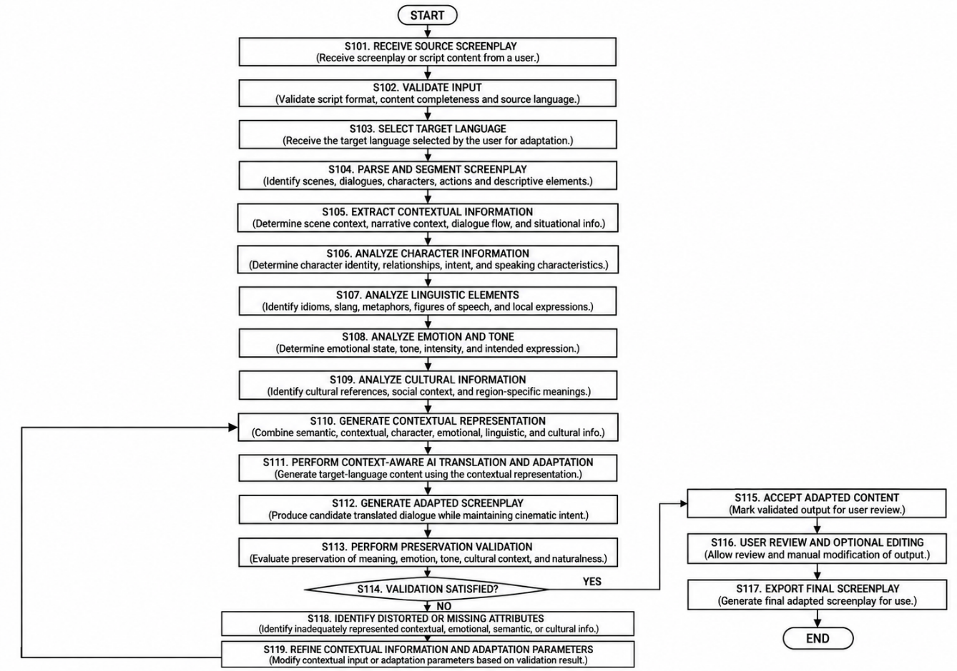

Fig. 2. Structural Diagram of the Proposed Idea.

